# INTRODUCTION

This project aims at solidifying the basics of front-end web development among students. Our goal was to make an e-commerce site, a blog, portfolio for each team members and a feed-back form. Working on this project will help us be familiar with the basics of HTML, CSS and JavaScript, which are an integral part of web development.

Our websites name is Origin Bonsai. We have tried our best to make a well-functioning and cohesive website using what we know. It was not easy to put everything together and make the website look good. Every team member had their own ideas and aspirations, to homologate all those different ideas into a website was the most difficult part. But I am confident that our team has done their best and has created a website we all are proud of.

## Goals

The main goal of this project is to make a e-commerce website with a blog, feed-back page and portfolio using vanilla JavaScript, HTML and CSS. We are not allowed to use any frameworks or libraries. This is to help us learn the fundamentals of how HTML, CSS and JavaScript works before diving into the more advance stuff. The website must be easy to navigate and lead to sales of bonsai.

## Objectives

1. To create a cohesive website that fulfills the requirement of our coursework
2. To showcase the individual talent and skills of our team members by creating a good-looking website

## How HTML, CSS and JS was used

HTML:

## Verdict

# DISCUSSION AND ANALYSIS

## Text Editor

Text editors are programs or word-processing software used to input and edit content. Text editors include, but are not limited to, WordPad, Notepad, Notepad++, Sublime Text, etc. (TechTerms.com, 2022).

For this project, the text editor of choice is Visual Studio Code, an IDE (Integrated Development Environment) program. Compared to other text editors, it is quite helpful since it has many features like prettier, which is a code formatter that neatly formats the code and makes it seem beautiful, go live, which enables editing HTML and seeing real-time changes without refreshing the browser.

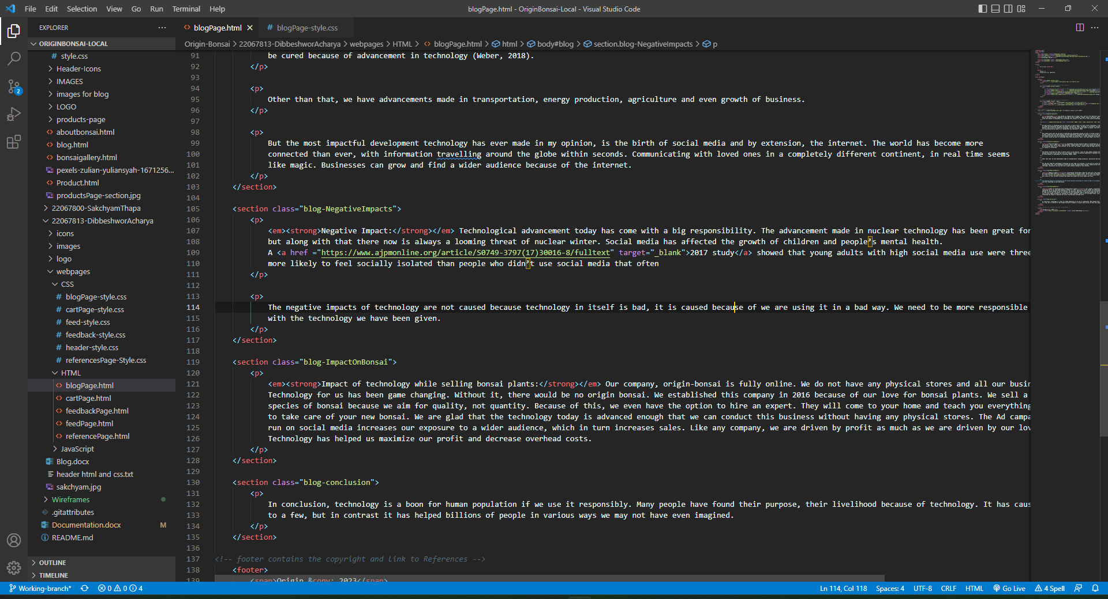

Figure : Vs-code

## Wireframe tool

When designing a website at the structural level, a wireframe tool is employed. Before adding visual layouts and content, they are used in the early stages of website development to create the fundamental framework of a page. (ExperienceUX, 2021).

The wireframe of the webpages in this project were designed using Balsamiq Wireframe. It is incredibly user-friendly and all the functions are simple to use.

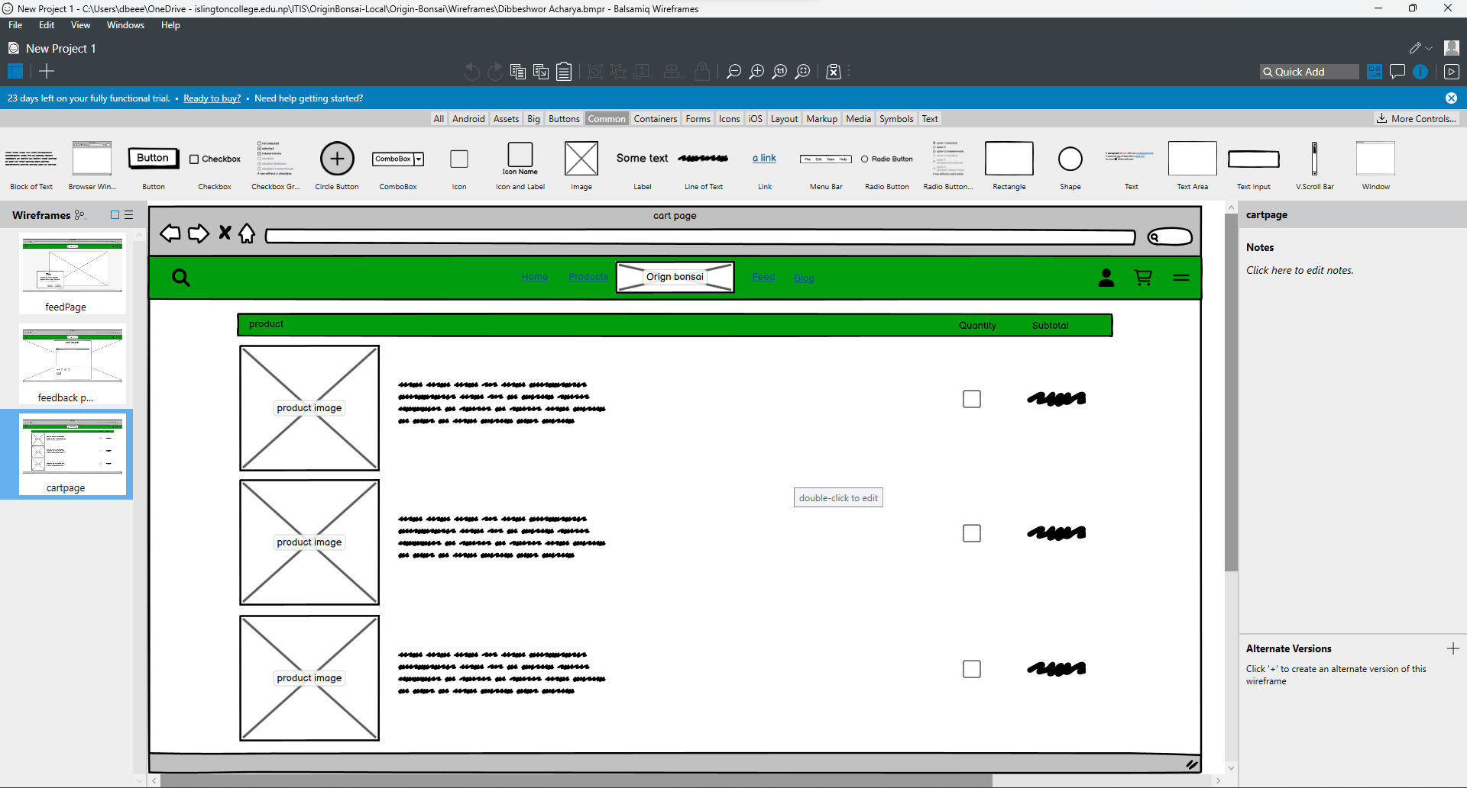

Figure : Balsamiq wireframe

# TESTING

## JavaScript Testing

### Testing Form validation for feed-back Page

Table : Test1: Form Validation

|  |  |
| --- | --- |
| Test No: | 1 |
| Objective: | To Test if form is accepted only when all fields are filled |
| Action: | * Leave one field in feedback form empty * Check if error alert is shown |
| Expected Result: | When form is not filled completely an error alert is shown |
| Actual Result: | Error alert was shown when the form was not filled successfully |
| Conclusion: | The test is successful |

Let’s leave a field empty

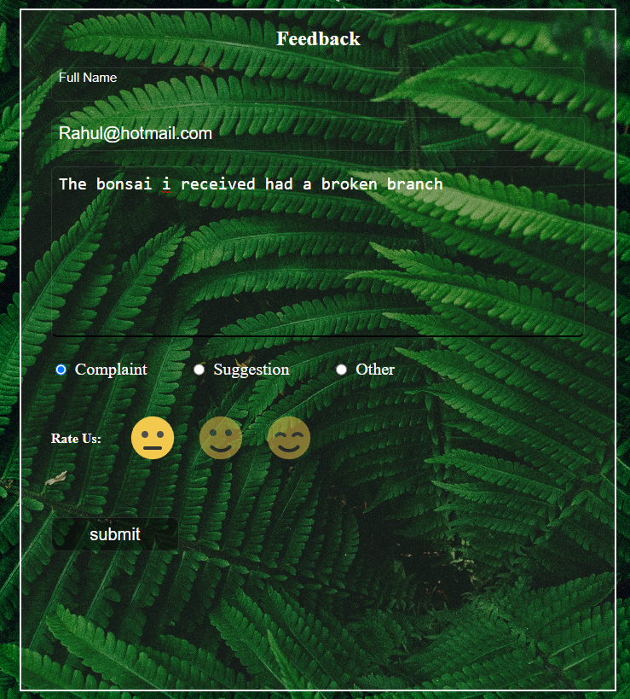

Figure : filling the form

As seen in the figure above, the name field has been left out empty. When we now try to submit this form, an error alert should be shown.

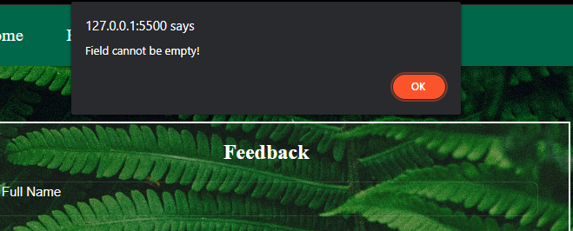

Figure : Error message for incomplete form

So, when we do not completely fill the form an error message is displayed.

### Testing “Rate Us:” emoji rating system

The emoji Rating System works by changing the opacity value of the selected emoji to 1 and the rest to 0.5. JavaScript is used to alter the CSS property of the images.

Table : Test 2: emoji rating

|  |  |
| --- | --- |
| Test No: | 2 |
| Objective: | To check if the emoji selector works |
| Action: | * Select lowest rating * Select middle rating |
| Expected Result: | When a selection is made, other emojis go back to being un-selected. |
| Actual Result: | When a selection was made, other emojis go back to being un-selected |
| Conclusion: | The test is successful |

We can see in the figure below when the lowest rating is selected, the other ratings become opaque automatically.

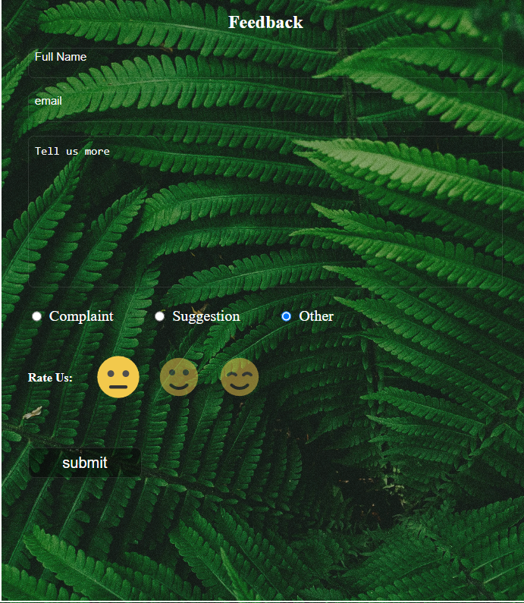

Figure : lowest rating

Accordingly, when we select the middle rating, the lowest rating gets opaque.

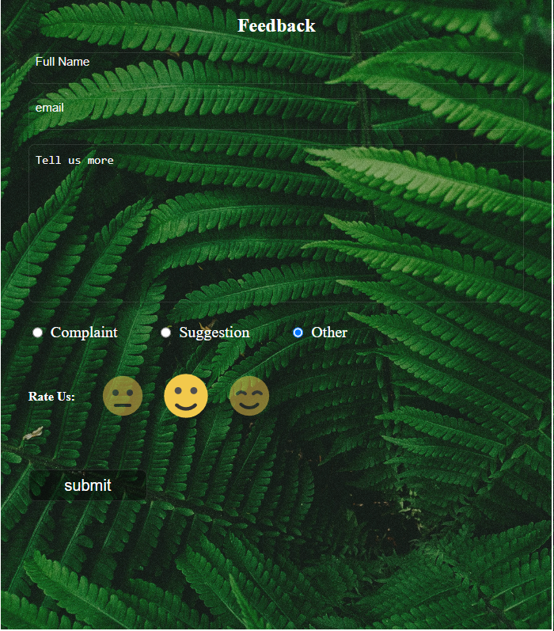

Figure : Middle rating

### Testing slider in feed page

The feed page contains a slider made using JavaScript. Along with images it scrolls text too.

Table : Test 3: Slider in Feed page

|  |  |
| --- | --- |
| Test No: | 3 |
| Objective: | To check if the feed slider works |
| Action: | * Click the next post arrow * Click the previous post arrow |
| Expected Result: | When next post arrow is selected, it scrolls to the next page and vice-versa |
| Actual Result: | The posts changed from next to previous |
| Conclusion: | The test is successful |

As seen in the images below, the next post and previous post arrows changes the posts accordingly.

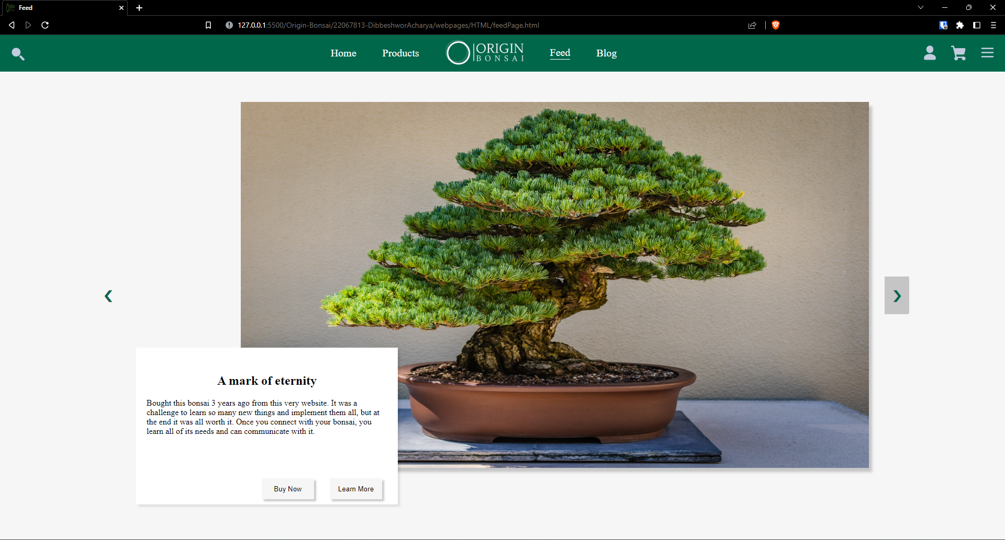

Figure : Before next button

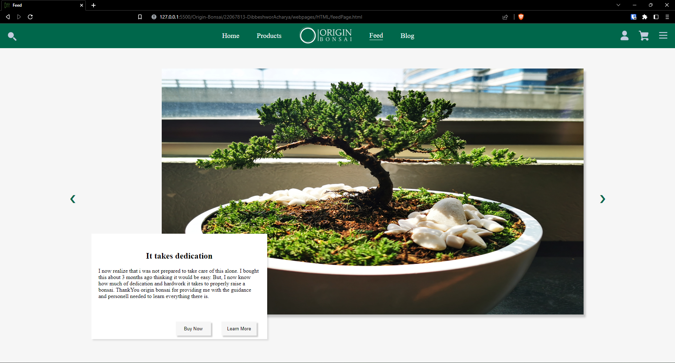

Figure : after next button

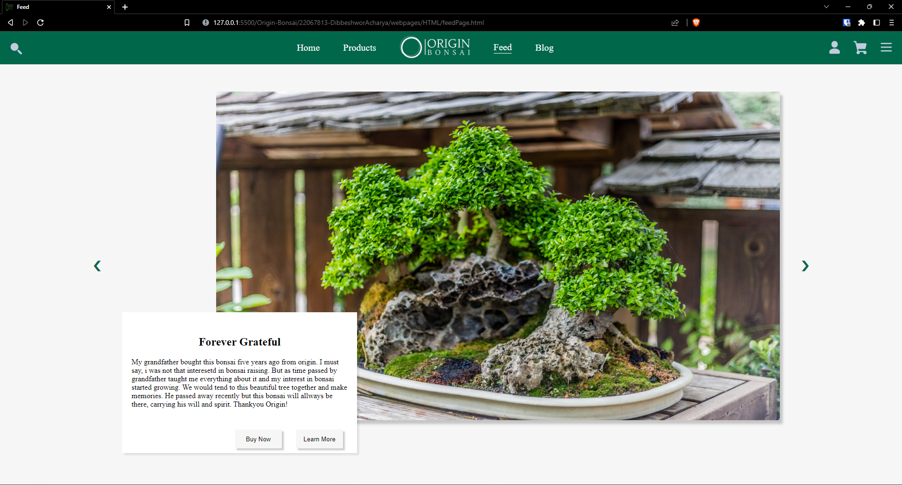

Figure : After previous button

## Navigation Hover Effect Testing

The header navigation elements have a hover effect added to them using CSS hover property. The element hovered over increase in size and is underlined.

Table : Test 4: nav hover testing

|  |  |
| --- | --- |
| Test No: | 4 |
| Objective: | To check if navigation hover effects work |
| Action: | * Hover mouse over navigation elements |
| Expected Result: | When mouse is hovered, the elements should increase in size and be underlined |
| Actual Result: | Hover effects were observed |
| Conclusion: | The test is successful |

As seen in the picture below, when mouse is hovered over the feed option, it is bigger in size than other elements and is underlined.

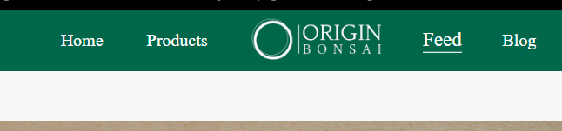

Figure : hover effect in nav bar

# CONCLUSION

In this coursework, HTML5, CSS3, and JavaScript were the primary focuses. The students are tasked with designing and developing an e-commerce website for a store that sells bonsai plants. The website must have at least 5 pages and meet guidelines for technology, design, and structure. The coursework is meant to demonstrate students' understanding of basic internet technologies, website design and development skills, and consideration of usability and accessibility. The accompanying documentation must include a cover page, a table of contents, an introduction, design and implementation details, testing results, and a reflection on the project. The goal of this coursework is to provide students with hands-on experience in creating a functional e-commerce website while considering various technical and design considerations.

As we worked on this project, we gained a lot of knowledge about HTML, CSS, and JS. Making an e-commerce website was a real-life prototype project that required us to create a working model of an actual e-commerce website. This coursework introduced us to various types of attributes and how and where to utilize them. It also broadened our understanding of JavaScript. It helped us comprehend how form validation works on a website. This project also helped us with our problem-solving abilities because we were having a lot of trouble with CSS and JS. While completing the assignment, the tutorial and workshop materials provided by the lecturer and tutor were quite useful.

Overall, despite our little understanding of HTML, CSS, and JavaScript, the project was enjoyable and hard. The difficulties encouraged us to conduct a study and exert extra effort to finish the job as effectively as feasible.

# APPENDIX